**POSITIONING SOCIAL ENTREPRENEURSHIP BETWEEN COMMERCIAL AND NONPROFIT ENTREPRENEURSHIP**

**INTRODUCTION**

**Social entrepreneurship in the last twenty years has captured the interests of practitioners, academia and the public alike (Short, Moss, & Lumpkin, 2009). Entrepreneurs increasingly adopt an integrative approach of business that combines economic, social, and environmental values into the so-called triple bottom line (Murphy & Coombes, 2009; Neck, Brush & Allen, 2009; Nga & Shamuganathan, 2010), aiming at the creation of social value for the society or the environment, the satisfaction of multiple business stakeholders who often have competing claims, and the sustainability of scalable solutions (Lumpkin**, Moss, Gras, Kato, & Amezcua**, 2013). Academics address this phenomenon as social entrepreneurship, offering multiple yet often inconsistent definitions (Bacq & Janssen, 2011; Short et al., 2009).**

**The majority of scholars claims that the social goals can be either an exclusive focus with no commercial exchanges, or the primary focus with a secondary attention to financial activities, regardless of the venture’s for-profit or nonprofit status. The importance of entrepreneurial opportunities that deliver both financial profit (Shane & Vekataraman, 2000) and maximize social impact is often ignored, as scholars have warned that an economic aim can take the focus away from the social cause the social enterprise has been set to support (Austin, Stevenson & Wei-Skillern, 2006; Santos, 2012; Santos, Pache & Birkholz, 2015; Stevens,** Moray, & Bruneel, 2015; **Zahra,** Gedajlovic, Neubaum, & Shulman**, 2009).**

**We cannot help but wonder whether social entrepreneurship is in need of a more refined comprehension. Through conducting a comprehensive literature review, we develop a continuum that expands from a profit focus to a social focus as the two components of a social entrepreneurship opportunity. We argue that ventures representing the social entrepreneurship territory are true to their description as social ventures when they showcase both social and entrepreneurial characteristics, namely by exploiting opportunities for both entrepreneurial profit and social impact. Therefore, in this study we use traditional commercial entrepreneurship as the proxy of entrepreneurial profit and non-profit entrepreneurship as the proxy of social impact and research their impact on social entrepreneurship. Our research question becomes: *Is Social Entrepreneurship impacted by the rate of commercial entrepreneurship and by the rate of non-profit entrepreneurship and what is the nature and extent of this impact?***

**With the help of data from the Global Entrepreneurship Monitor, we show that social entrepreneurship is positively impacted by both non-profit and commercial entrepreneurship in a market. More specifically, non-profit entrepreneurship highly influences the rate of social entrepreneurship, increasing entrepreneurs’ efforts to deliver social impact, while commercial entrepreneurship also influences social entrepreneurship but at a smaller scale.**

**The rest of the paper is structured as follows: First, we present the background literature on social entrepreneurship and identify the theoretical gaps with regard to the existing definitions, which leads to our two hypotheses. The research design and methodology used in this paper come next. Finally, we present our empirical results that reveal a positive influence of non-profit and commercial entrepreneurship on social entrepreneurship.**

**BACKGROUND: UNDERSTANDING SOCIAL ENTREPRENEURSHIP**

**Social entrepreneurship has been defined in various and often inconsistent ways, provoking academic criticism of the existing definitions as either too broad (Martin & Osberg, 2007) or too narrow (Light, 2006). Following preceding academic efforts to organize various business forms in typologies (Dorado, 2006; Hartigan, 2006; Lepoutre,** Justo, Terjesen, & Bosma**, 2013; Neck et al., 2009; Peredo & McLean, 2006; Townsend & Hart, 2008; Wilson & Post, 2013), we present a continuum that differentiates social ventures from other venture forms and from social activities of existing organizations, according to the ventures’ stance toward social and financial foci (Figure 1). The term social entrepreneurship introduces both entrepreneurial and social properties, typically found in traditional entrepreneurship and nonprofit literature respectively. Therefore, on the one end of the continuum and influenced by traditional entrepreneurship literature we position profit as the key component of the venture’s entrepreneurial opportunity (Schumpeter, 1934; Kirzner, 1997, Shane & Venkataraman, 2000). We define profit “as the value captured by the organization for its owners (shareholders in a public company, or partners in a partnership model, or members in a cooperative model)” (Santos et al., 2015: 39). On the other end of the continuum we introduce social properties typically found in nonprofit research (e.g.** Galaskiewicz, Bielefeld, & Dowell, 2006**; Moore, 2001). The social impact as a focal component of a social entrepreneurship opportunity (Katre & Salipante, 2012) is primarily depicted in the venture’s social mission, which directs the venture in terms of its strategy and priorities (Moss, Short, Payne & Lumpkin, 2010; Stevens et al., 2015). This is what primarily distinguishes social from traditional entrepreneurship (Lumpkin et al., 2013; Martin & Osberg, 2007).**

**For simplicity purposes, our continuum hosts three fundamental venture types as discussed in the current literature, namely for-profit ventures, not-for-profit ventures and hybrid or social ventures.**

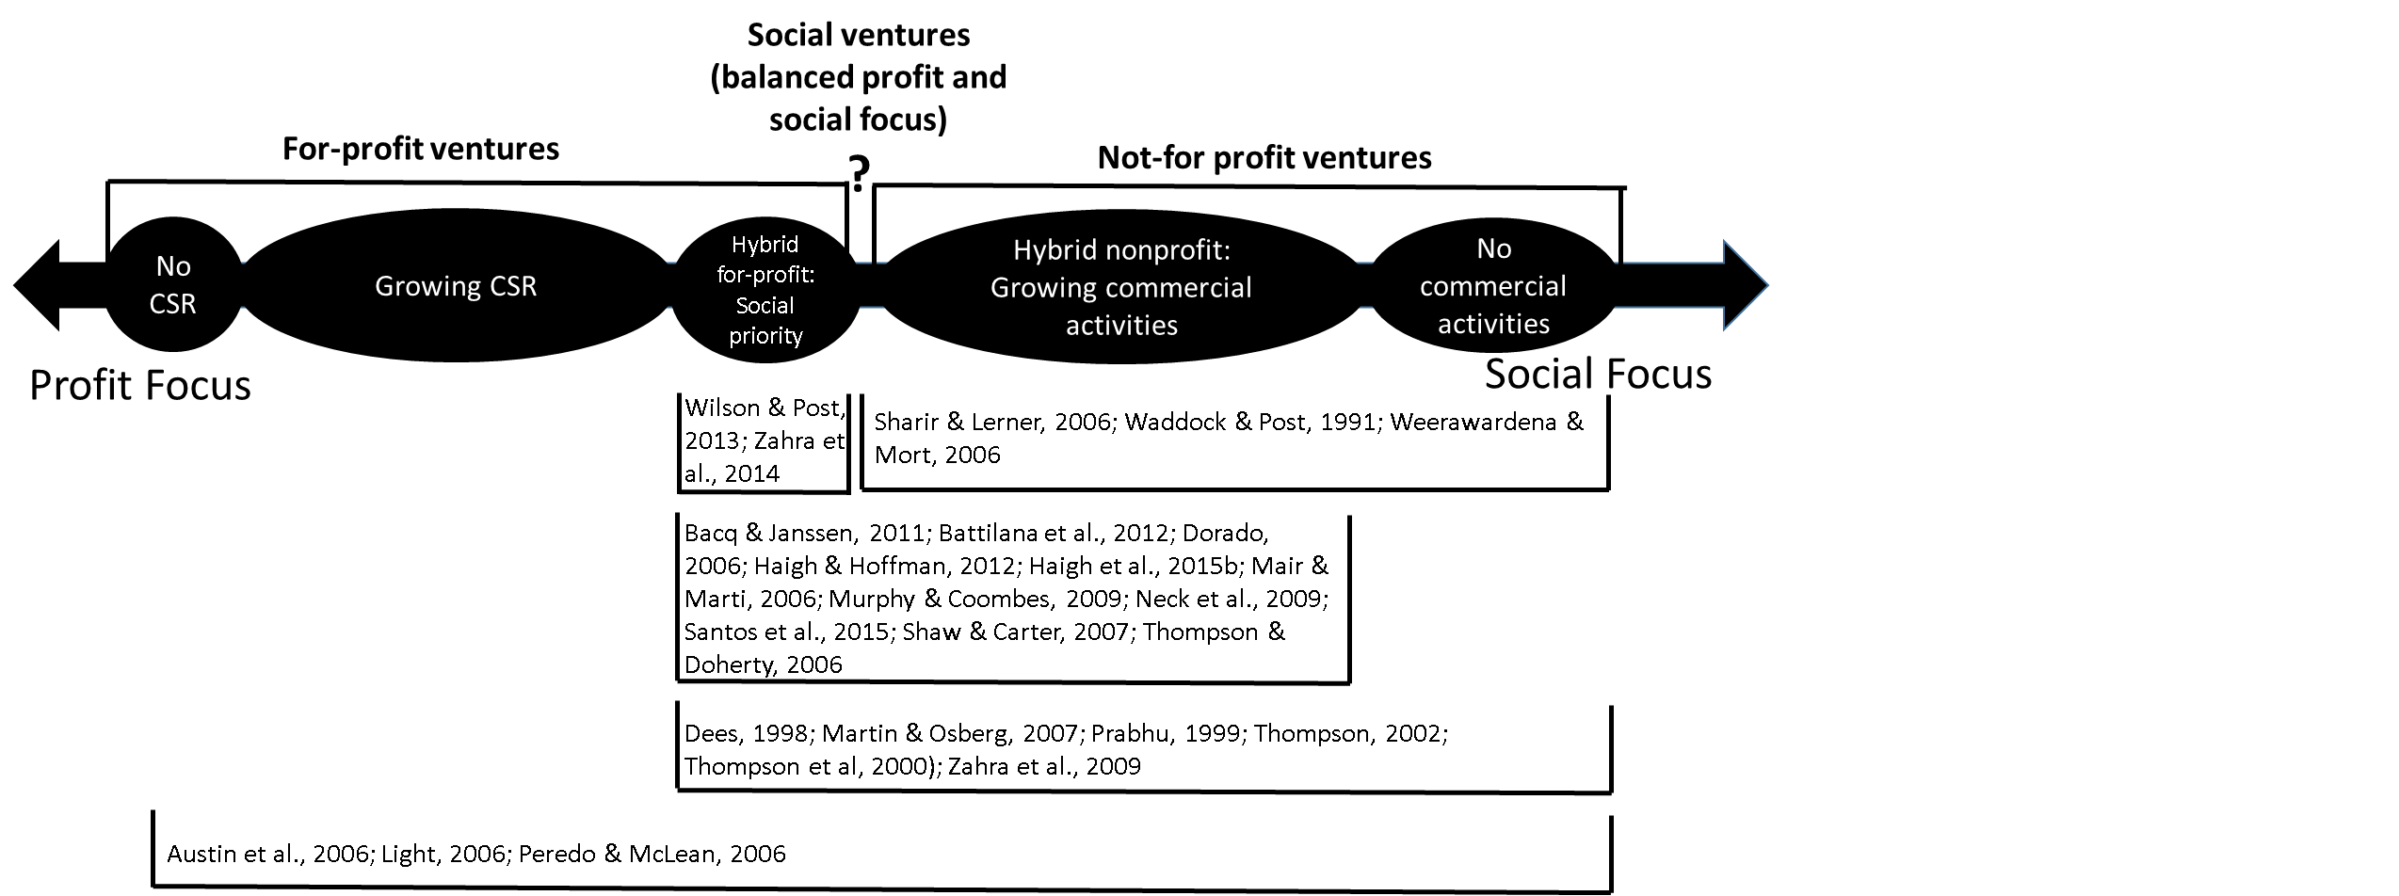

***Figure 1: The Social Entrepreneurship Continuum***

**On the one end of the continuum are the for-profit ventures, firms primarily interested in financial activities and profit, and mainly following the self-focused profit interests of the entrepreneurs (Austin et al., 2006; Battilana, Lee, Walker, & Dorcey, 2012; Lumpkin et al., 2013). They may have no social interest or a peripheral focus on corporate social responsibility (CSR). When the companies execute some form of CSR that is financed by their own profits, and depending on how much effort they put on social causes, they move along the continuum towards what we define as a social venture.**

**On the other end of the continuum we place the not-for-profit ventures, the starring actors in nonprofit literature. Various scholars have only examined nonprofits in their efforts to explore social entrepreneurship (e..g Haugh, 2007; Waddock & Post, 1991; Weerawardena & Mort, 2006) as, put very eloquently, “the main world of the social entrepreneur is the voluntary sector” (Thompson, 2002: 413). Charitable purposes are pursued primarily through external funds in the shape of philanthropy, donations, and private funding, and these efforts aim to help disadvantaged societal groups through redistributing resources (Battilana et al., 2012; Santos, 2012). These ventures usually have a not-for-profit legal or tax status, but increasingly focus on the production of marketable goods and services as a means of income (Lumpkin et al., 2013; Zahra et al., 2009). The differentiating point is that, even when commercial activities are performed and revenues are collected (as per the social or hybrid venture type we present next), the primary goal is not to maximize stakeholder value (Murphy & Coombes, 2009) and the revenues are instead reinvested in the social venture (Haugh, 2007; Peredo & McLean, 2006) in a means-end relationship.**

**Moving towards the middle of our continuum, what many scholars have defined as hybrid or social ventures are enterprises that use commercial operations to serve a social cause by designing “their products, operating models, brands, and technologies from the ground up to align with the goal of social and environmental sustainability” (Lee & Jay, 2015: 127).** These ventures are gaining ground in the practitioners’ world. **Compared to commercial entrepreneurship that is primarily profit-driven with a focus on consumer needs normally well beyond the basic needs of society, social entrepreneurship is derived from more collective-focused aspirations and opportunities to address issues that are often well known, including community support, wealth sharing and transformational benefits for society as a whole (Lumpkin et al., 2013; Martin & Osberg, 2007). Profit becomes the means to achieve sustainability and scalability of the solutions (Dees, 2007; Lumpkin et al., 2013; Santos, 2012), and a**s t**he social mission supersedes every other priority (Bacq & Janssen, 2011; Mair & Marti, 2006), it does not come as a surprise that** non-profit ventures have been included in the forms that hybrid social entrepreneurship can take (e.g. Battilana et al., 2012; Haigh & Hoffman, 2012; **Haigh, Kennedy & Walker, 2015a; Haigh et al., 2015b; Santos et al., 2015).**

**We base our research on the framework of traditional entrepreneurship and therefore argue that social entrepreneurship identifies entrepreneurial opportunities (Shane & Venkataraman, 2000) and executes the carrying out of new combinations in the pursuit of profit (Schumpeter, 1934), but also has a clear and succinct mission embedded in the day-to-day operations and its business model, and that is to create sustainable social benefits*,* or to give back to society and the environment in some way (**Galaskiewicz et al., 2006; **Moore, 2001). As our interpretation of social entrepreneurship includes both social and entrepreneurial characteristics, we theorize that it is positively impacted by the presence of both traditional and nonprofit entrepreneurship in a market. We accordingly develop two hypotheses, also represented in Figure 2 as our base conceptual framework. We then turn to our data to explore the truth of these hypotheses.**

***H1: Social Entrepreneurship is positively impacted by the rate of commercial entrepreneurship in a market.***

***H2: Social Entrepreneurship is positively impacted by the rate of non-profit entrepreneurship in a market.***

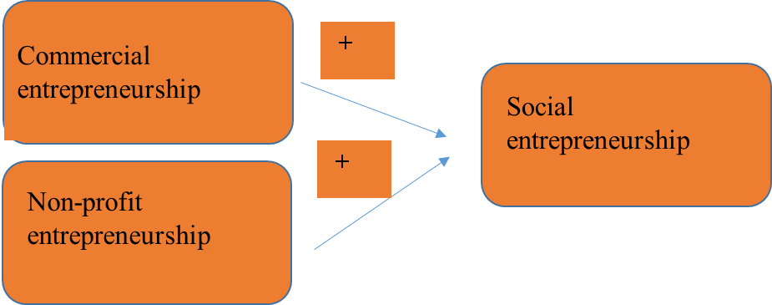

***Figure 2: Theoretical framework of Social Entrepreneurship***

**EMPIRICAL DESIGN AND METHODOLOGY**

**Data Sets and Variables**

In order to test our hypotheses, we utilize a variety of datasets produced by the Global Entrepreneurship Monitor (GEM) in 2009, including a unique dataset on social entrepreneurship covering more than 114,000 individuals in 40 countries around the world (Figure 3), as well as the adult population and national expert studies available for those countries.

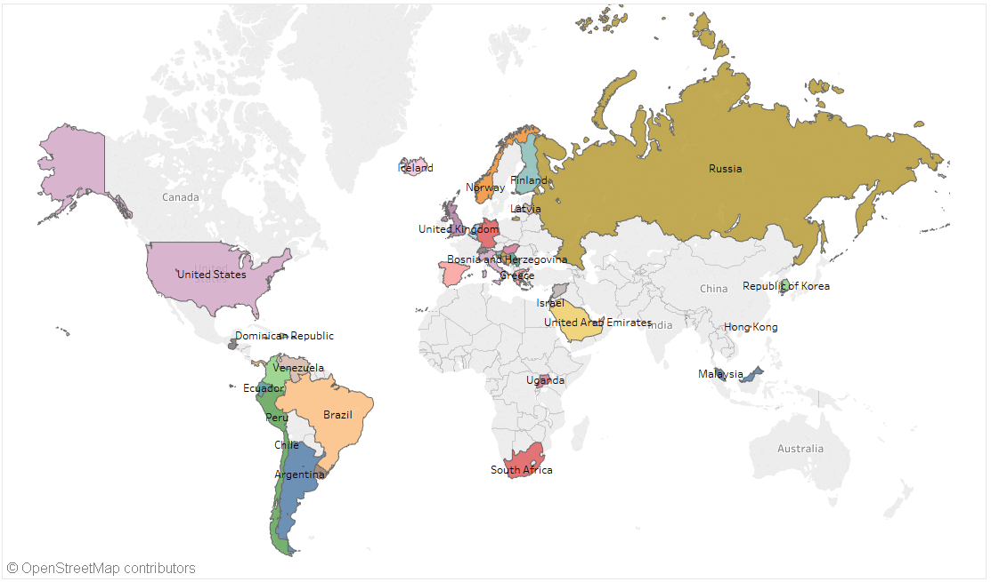

***Figure 3: Countries included in GEM report***

With only a few exceptions, the data from each country includes a sample of at least 2,000 individuals that belong in the working age population. It is also worth mentioning that even though social entrepreneurship research has primarily focused on case studies due to a lack of quantitative data available (Short et al., 2009), scholars increasingly attempt to utilize GEM data and especially the 2009 report on social entrepreneurship in their SE studies **(Bacq, Hartog & Hoogendoorn, 2013; Griffiths, Gundry, & Kickul, 2013; Lepoutre et al., 2013)**. Next we present Figure 4 and 5 to help our readers understand the entrepreneurship ratios by geographical region.

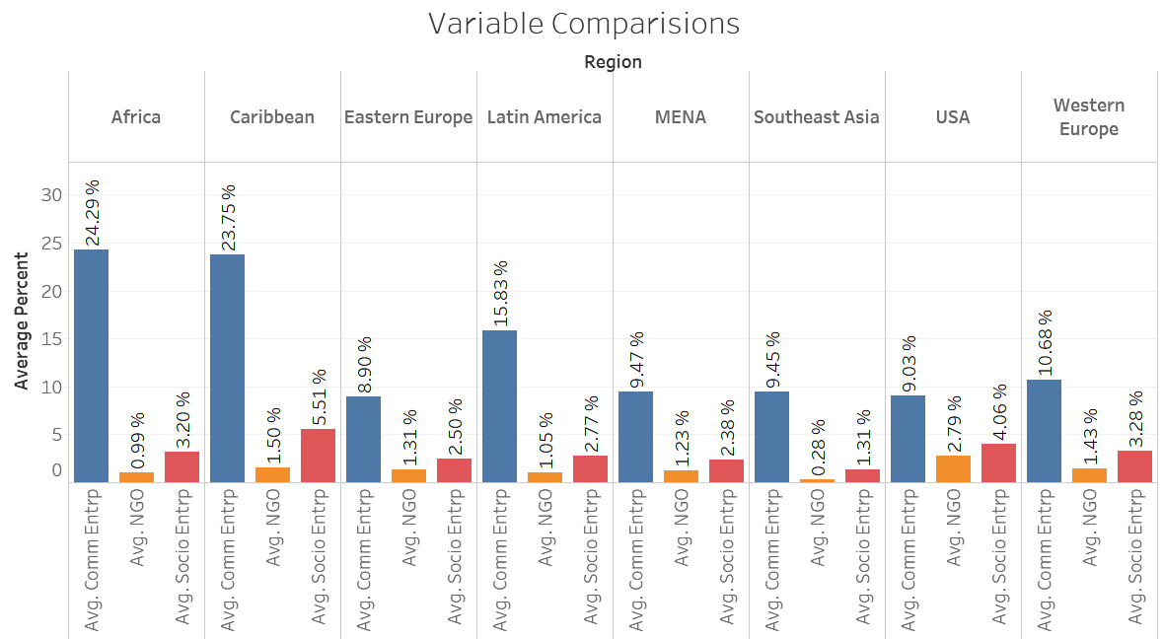

***Figure 4: Entrepreneurship ratio by region***

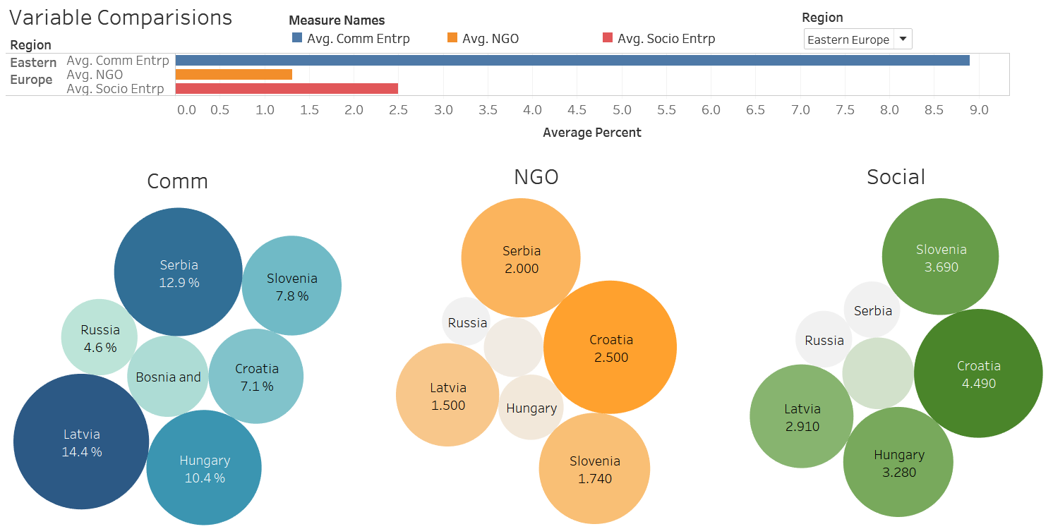

***Figure 5: Example of country entrepreneurship ratios by region***

***Dependent variable:*** The 2009 social entrepreneurship report introduces traditional NGOs, non-profit social enterprises with some financial activity, **economically oriented hybrid social enterprises, socially oriented hybrid social enterprises and for-profit social enterprises as different forms social entrepreneurship can undertake, as per Figure 6.**

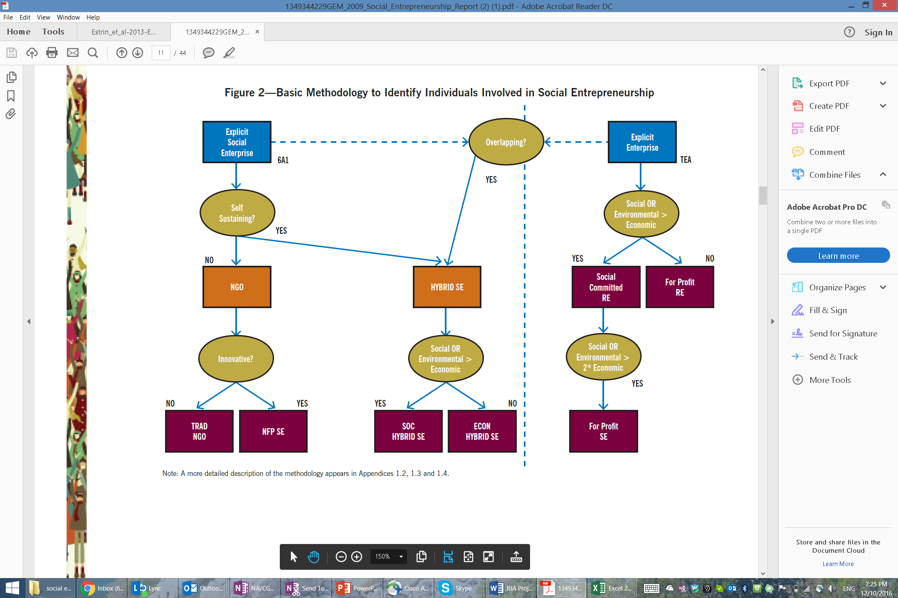 ***Figure 6: Social Entrepreneurship forms as per GEM report***

**However, we remind our readers that our interpretation of social entrepreneurship introduces both social and entrepreneurial characteristics, therefore only accepts one portion of what GEM presents. We argue that social entrepreneurship only consists of ventures that have a dual focus of delivering profit and maximizing social impact.Therefore, we construct the dependent variable *Socio_Entrp* by combining the social entrepreneurship rates of economically oriented hybrid social enterprises, socially oriented hybrid social enterprises and for-profit social enterprises by country and leave out the forms of NGOs and non-profit social enterprises, as the main focus of these companies is the social impact and not the profit maximization.**

***Independent variables (H1, H2):*** To test for H1, we construct the variable of commercial entrepreneurship (*Comm_Entrp_IV*) with the help of data from the adult population study by GEM in 2009. We combine the new business with the established business ownership rates to develop the independent variable that represents both new and existing commercial entrepreneurship in a country. The new business ownership rate is the percentage of 18-64 year-old population who are currently an owner or manager of a new business, i.e., owning and managing a running business that has paid salaries, wages, or any other payments to the owners for more than three months, but not more than 42 months. The established business ownership rate is the percentage of 18-64 year-old population who are currently an owner or manager of an established business for more than 42 months. To test for H2, we go back to the social entrepreneurship report by GEM in 2009 and combine the two forms of social entrepreneurship we left out of our dependent variable, namely traditional **NGOs and non-profit social enterprises. These forms comprise our *NGO_IV* variable.**

***Control variables:*** The GEM national experts’ survey provides us with the variables we control our model for. We control for 1) financial support (*financing*) for enterprises that can take the form of grants and subsidies available to entrepreneurs, 2) government policies (*govt_support*) like regulation that can either be neutral or favorable to the establishment of enterprises, 3) the extent to which taxes support entrepreneurship per country (*tax_bureacracy*), 4) government programs (*gov_program*) at all levels (national, regional, municipal) that can also support entrepreneurship, 5) basic school entrepreneurship education (*basic_entrp_training*) at primary and secondary levels, 6) post-school entrepreneurship education and training (post_entrp_training) in colleges, business schools etc., 7) research and development (*RD*) and the extent to which it is available and will lead to new venture creation, 8) the presence of commercial and professional infrastructure (*comm_prof_infra*) or property rights, commercial, accounting and other legal and assessment services and institutions that support or promote enterprises, 9) internal market dynamics (i*nt_mark_dynamics*) or the level of change in markets from year to year, 10) internal market openness (*int_markt_openess*) or the extent to which new firms are free to enter existing markets, 11) ease of access to physical resources (*phy_serv_infra*) at a price that does not deter newcomers from entering, and 12) cultural and social norms (cult_social_norms) and the extent to which they encourage new business activities that aim at personal wealth creation.

Below we include two tables that present the variables we use in our analysis:

|  |  |  |
| --- | --- | --- |
| Description | Variable Type | SAS Variable Name |
| social entrepreneurship | Dependent | Socio_Entrp |
| commercial entrepreneurship | Independent | Comm_Entrp_IV |
| non-profit entrepreneurship | Independent | NGO_IV |

|  |  |  |
| --- | --- | --- |
| **Control variables** | | |
| Name | Description | SAS Variable Name |
| **Financing for entrepreneurs** | The availability of financial resources—equity and debt—for small and medium enterprises (SMEs) (including grants and subsidies) | **Financing** |
| **Governmental support and policies** | The extent to which public policies support entrepreneurship - as a relevant economic issue | **Govt_support** |
| **Taxes and bureaucracy** | The extent to which public policies support entrepreneurship - taxes or regulations are either size-neutral or encourage new and SMEs | **Tax_bureaucracy** |
| **Governmental programs** | The presence and quality of programs directly assisting SMEs at all levels of government (national, regional, municipal) | **Gov_program** |
| **Basic-school Entrepreneurial Education and training** | The extent to which training in creating or managing SMEs is incorporated within the education and training system at primary and secondary levels | **Basic_entrp_training** |
| **Post-school entrepreneurial education and training** | The extent to which training in creating or managing SMEs is incorporated within the education and training system in higher education such as vocational, college, business schools, etc. | **Post_entrp_training** |
| **R&D Transfer** | The extent to which national research and development will lead to new commercial opportunities and is available to SMEs | **RD** |
| **Commercial and professional infrastructure** | The presence of property rights, commercial, accounting and other legal and assessment services and institutions that support or promote SMEs | **Comm_prof_infra** |
| **Internal market dynamics** | The level of change in markets from year to year | **int_mark_dynamics** |
| **Internal market openness** | The extent to which new firms are free to enter existing markets | **Int_markt_openness** |
| **Physical and services infrastructure** | Ease of access to physical resources—communication, utilities, transportation, land or space—at a price that does not discriminate against SMEs | **Phy_serv_Infra** |
| **Cultural and social norms** | The extent to which social and cultural norms encourage or allow actions leading to new business methods or activities that can potentially increase personal wealth and income | **Cult_Social_norms** |

**RESULTS**

In our paper we use multiple linear regression through SAS. We first introduce control variables. However, before integrating all of them into the model, we check whether they are correlated and can be introduced into the model as groups.

SAS code:

**proc** **import** datafile="C:\Multivariate Data Analytics\Project\soc_dat.csv" out=soc_data dbms=csv replace;

**run**;

title "Correlation between control variables";

**proc** **corr** data=soc_data ;

var Financing Govt_support Tax_bureaucracy Gov_program Basic_entrp_training Post_entrp_training RD Comm_prof_infra int_mark_dynamics Int_markt_openness Phy_serv_Infra Cult_Social_norms;

**run**;

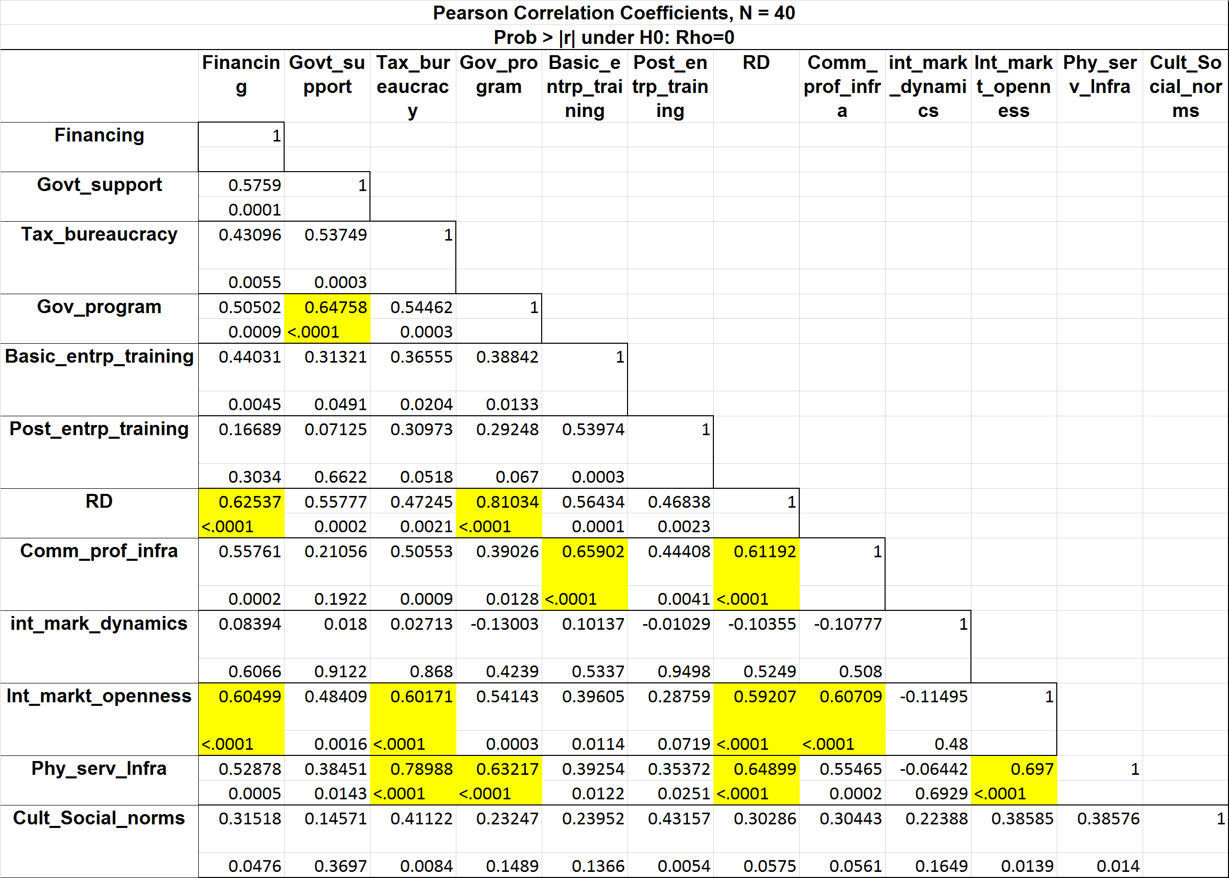

Since correlation does exist, we follow a variable reduction procedure using principal component method with Proc Factor.

**Proc** **factor** data=Social_entrp_data method=principal scree;

var Fianancing Govt_support Tax_bureaucracy Gov_program Basic_entrp_training Post_entrp_training RD Comm_prof_infra int_mark_dynamics Int_markt_openness Phy_serv_Infra Cult_Social_norms;

**run**;

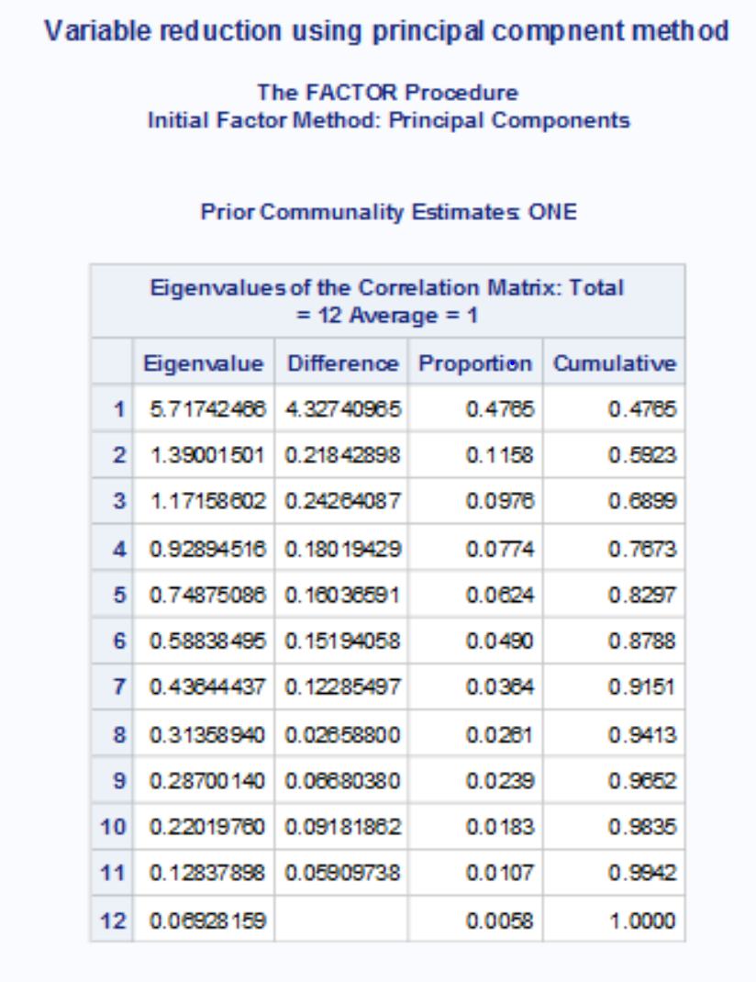

We retain enough components so that the cumulative percent of variance is closest to 85%. Therefore 5 components are kept. We use varimax rotation (orthogonal rotation) which results in uncorrelated components and gives distinguishable factor loadings. In the principal component analysis we select nfactor=5 and rotation=varimax.

SAS Code:

title "Factor anaysis with 5 factors and varimax rotation ";

**Proc** **factor** data=soc_data method=principal nfactor=**5** rotate=varimax scree out=Social_data_factors;

var Financing Govt_support Tax_bureaucracy Gov_program Basic_entrp_training Post_entrp_training RD Comm_prof_infra int_mark_dynamics Int_markt_openness Phy_serv_Infra Cult_Social_norms;

**run**;

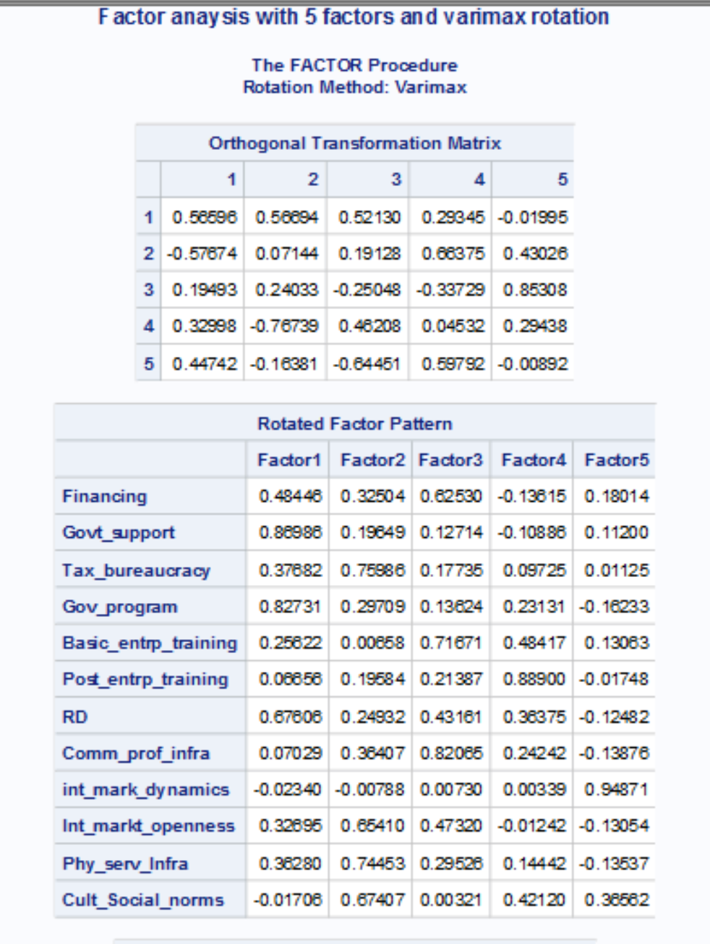

|  |  |  |  |  |  |
| --- | --- | --- | --- | --- | --- |
| **Rotated Factor Pattern** | | | | | |
|  | **Factor1** | **Factor2** | **Factor3** | **Factor4** | **Factor5** |
| **Financing** | 0.48446 | 0.32504 | **0.6253** | -0.1362 | 0.18014 |
| **Govt_support** | **0.86986** | 0.19649 | 0.12714 | -0.1089 | 0.112 |
| **Tax_bureaucracy** | 0.37682 | **0.75986** | 0.17735 | 0.09725 | 0.01125 |
| **Gov_program** | **0.82731** | 0.29709 | 0.13624 | 0.23131 | -0.1623 |
| **Basic_entrp_training** | 0.25622 | 0.00658 | **0.71671** | 0.48417 | 0.13063 |
| **Post_entrp_training** | 0.06656 | 0.19584 | 0.21387 | **0.889** | -0.0175 |
| **RD** | **0.67606** | 0.24932 | **0.43161** | 0.36375 | -0.1248 |
| **Comm_prof_infra** | 0.07029 | 0.36407 | **0.82065** | 0.24242 | -0.1388 |
| **int_mark_dynamics** | -0.0234 | -0.0079 | 0.0073 | 0.00339 | **0.94871** |
| **Int_markt_openness** | 0.32695 | **0.6541** | 0.4732 | -0.0124 | -0.1305 |
| **Phy_serv_Infra** | 0.3628 | **0.74453** | 0.29526 | 0.14442 | -0.1354 |
| **Cult_Social_norms** | -0.0171 | **0.67407** | 0.00321 | 0.4212 | 0.36562 |

Next we group and name the factors as well as rename them in the dataset:

|  |  |  |
| --- | --- | --- |
| **Factor1** | Govt_support, Gov_program, RD | **Gov_RD_Support** |
| **Factor2** | Tax_bureaucracy, Int_markt_openness, Phy_serv_Infra, Cult_Social_norms | **Market infrastructure** |
| **Factor3** | Financing, Basic_entrp_training, Comm_prof_infra | **Institutional Support** |
| **Factor4** | Post_entrp_training | **Post_entrp_training** |
| **Factor5** | int_mark_dynamics | **int_mark_dynamics** |

SAS Code:

**Data** Social_data_factors;

rename Factor1=Gov_RD_Support

Factor2=Market_infrastructure

Factor3=Institutional_Support

Factor4=Post_entrp_training_Comp

Factor5=int_mark_dynamics_comp;

set Social_data_factors;

**run**;

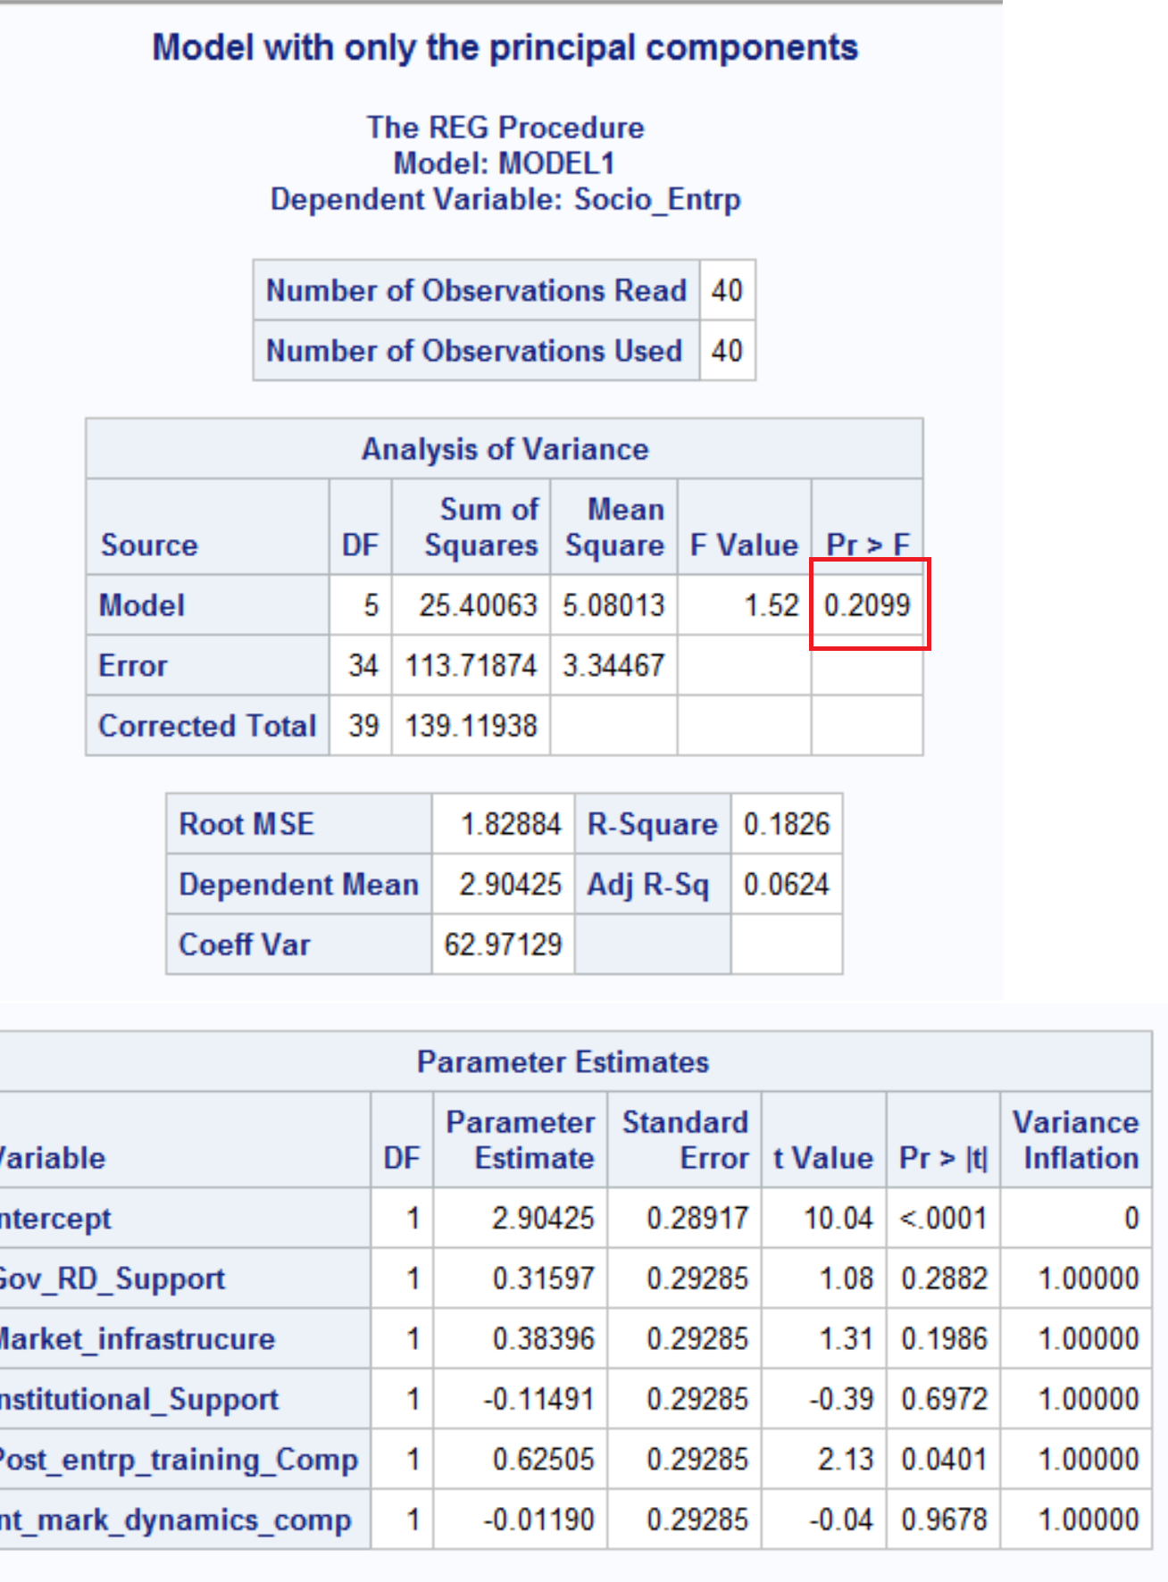

We see that the model is not a good fit as the Global F test value is not significant. We then analyze the relationship of response: “Socio_Entrp” to predictors: Comm_Entrp_IV and NGO_IV.

title "Regression of Socio_Entrp vs Comm_Entrp_IV NGO_IV";

**proc** **reg** data=soc_data ;

model Socio_Entrp= Comm_Entrp_IV NGO_IV ;

**run**;

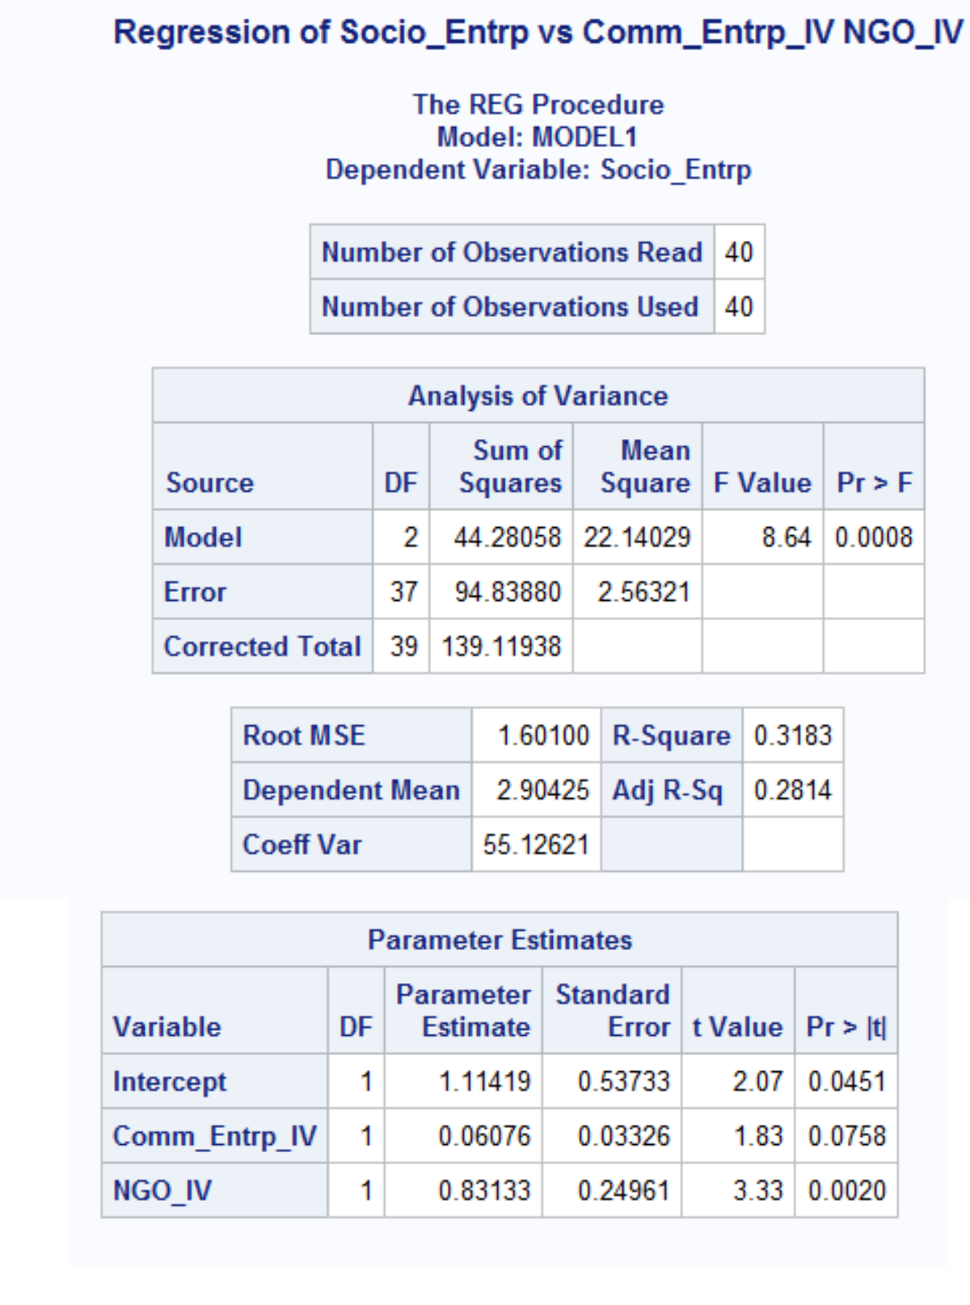

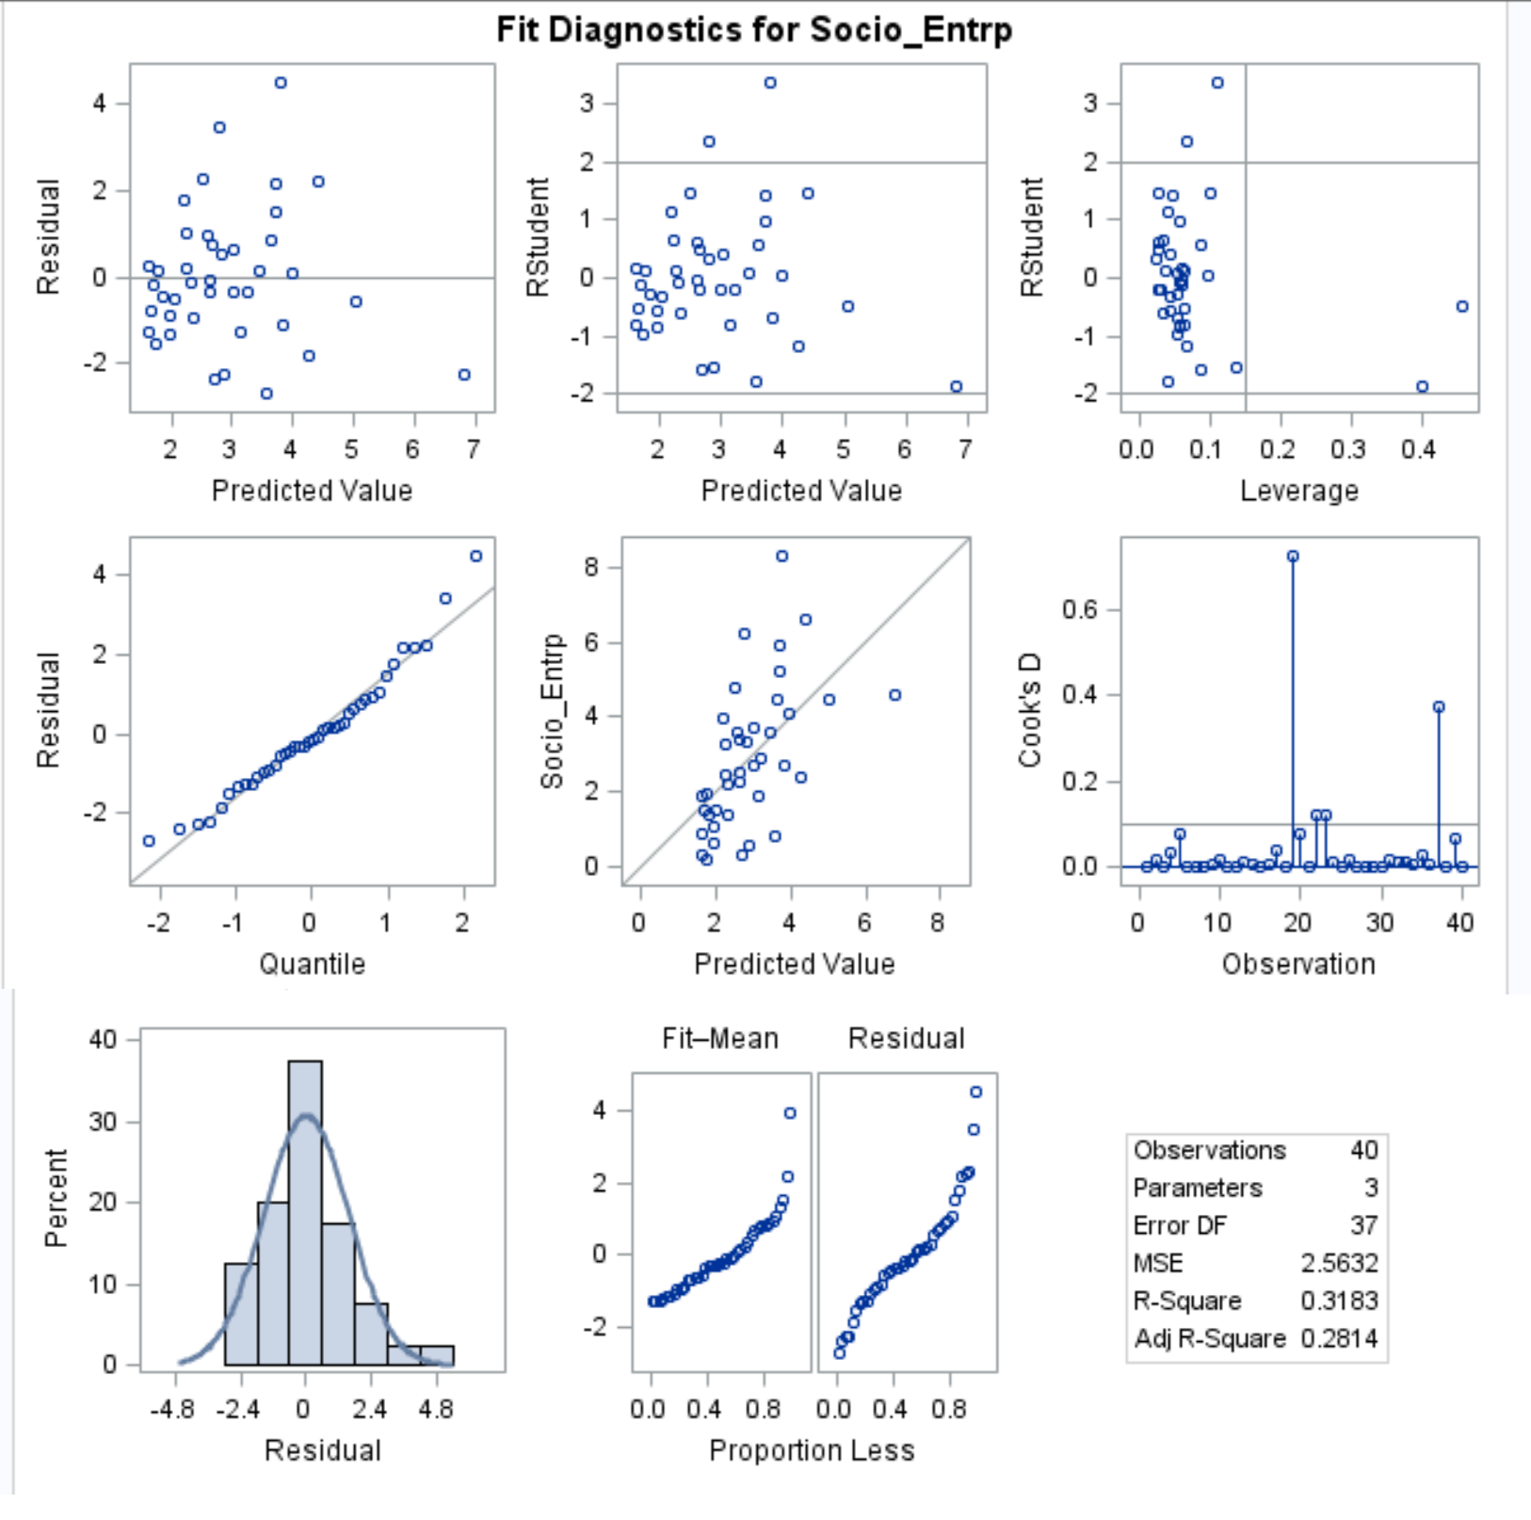

With 5% confidence interval, we observe that the model is good with F test value of 0.0008 and R square of 32 %. We also see that the predictor NGO_IV is significant.

We then proceed with introducing one independent variable at a time to the base model that includes the 5 factors:

title "Model with only the principal components and Comm_Entrp_IV";

**proc** **reg** data=Social_data_factors ;

model Socio_Entrp= Comm_Entrp_IV Gov_RD_Support Market_infrastrucure Institutional_Support

Post_entrp_training_Comp int_mark_dynamics_comp/vif ;

**run**;

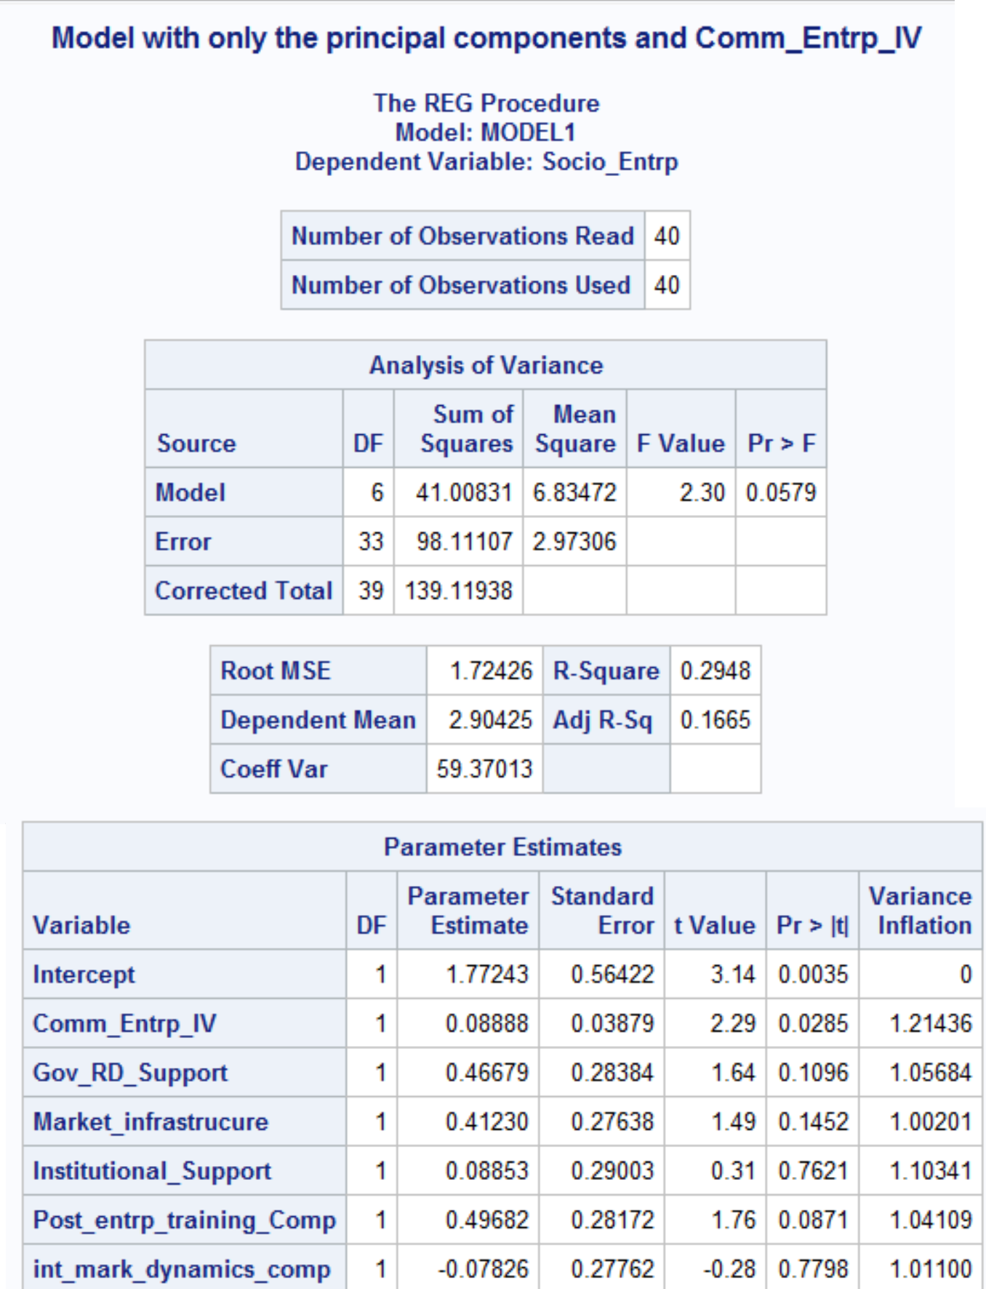

title "Model with only the principal components and NGO_IV";

**proc** **reg** data=Social_data_factors ;

model Socio_Entrp= NGO_IV Gov_RD_Support Market_infrastrucure Institutional_Support

Post_entrp_training_Comp int_mark_dynamics_comp/vif ;

**run**;

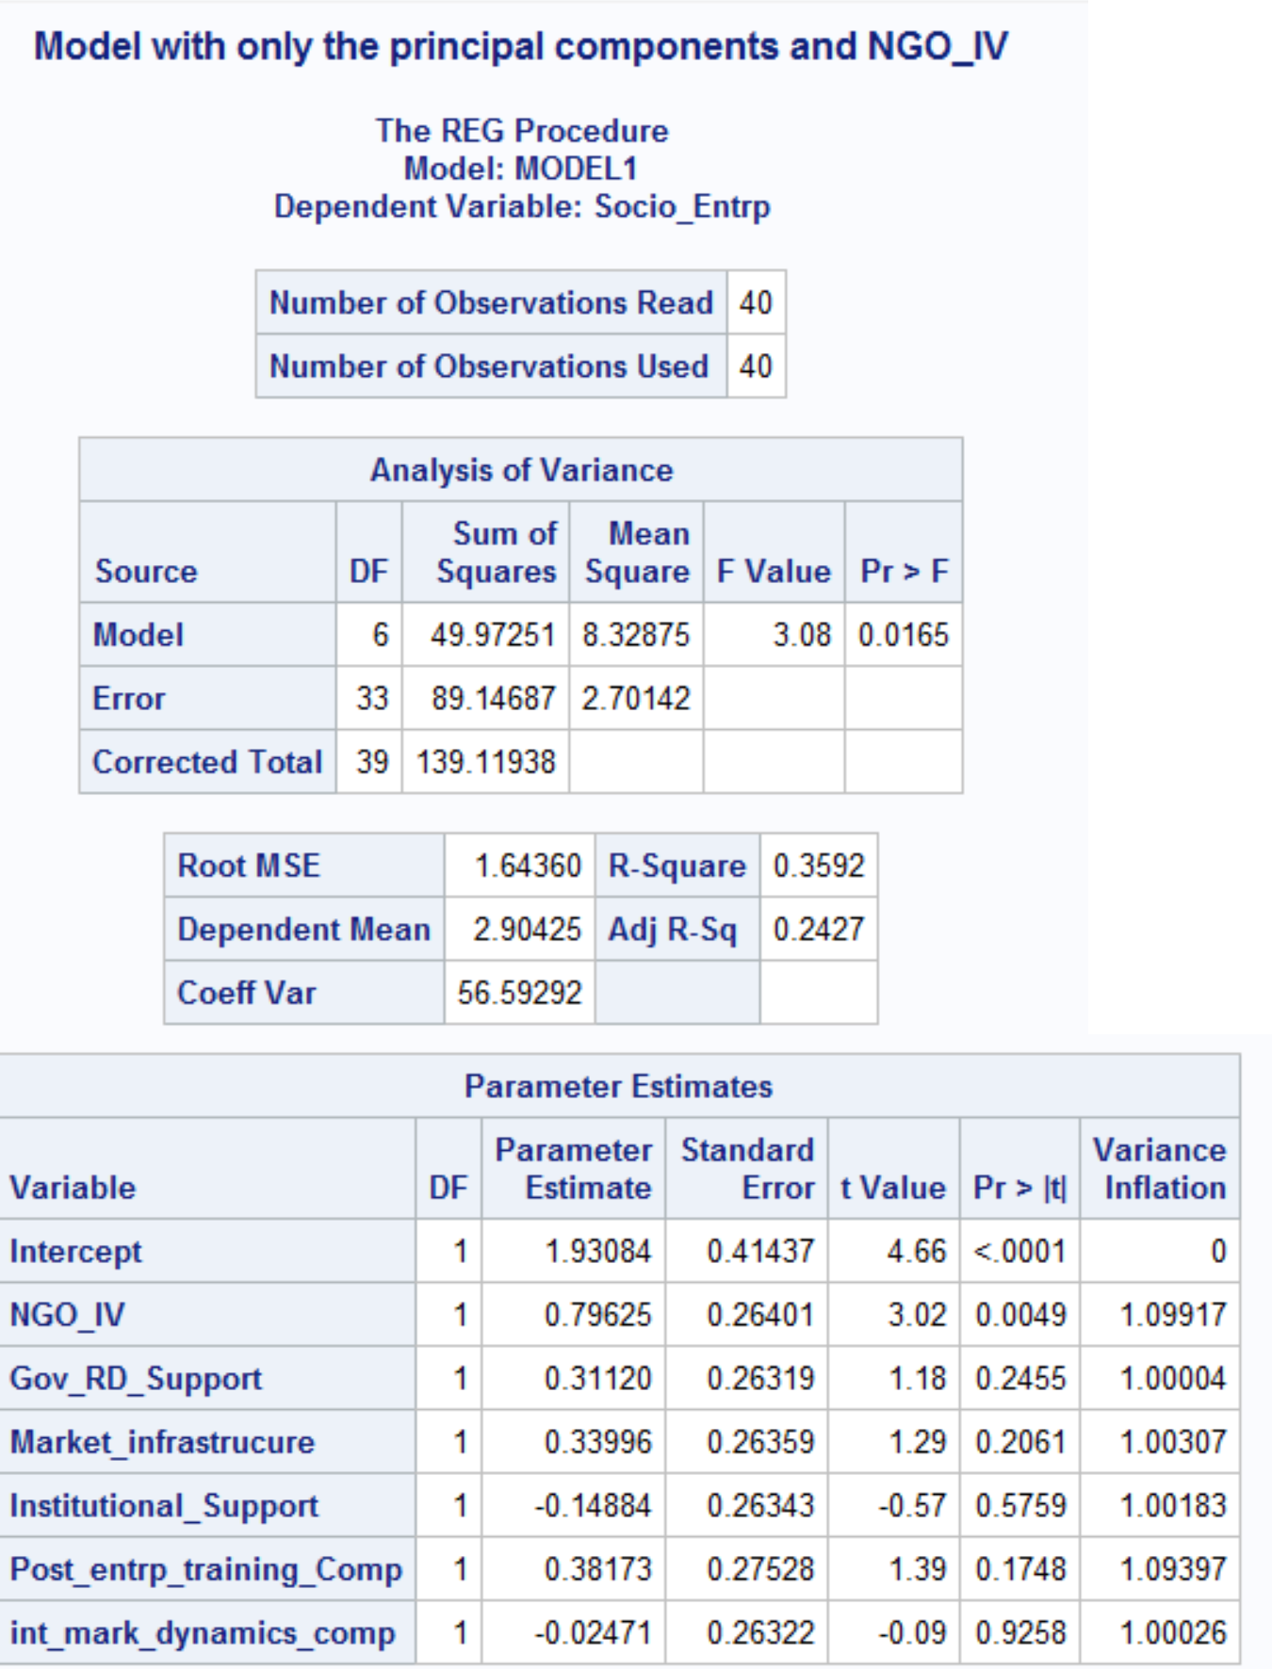

And we finally introduce all variables in our model (5 factors and 2 independent variables):

title "Model with the principal components, Comm_Entrp_IV, NGO_IV";

**proc** **reg** data=Social_data_factors ;

model Socio_Entrp= NGO_IV Comm_Entrp_IV Gov_RD_Support Market_infrastrucure Institutional_Support

Post_entrp_training_Comp int_mark_dynamics_comp/vif ;

**run**;

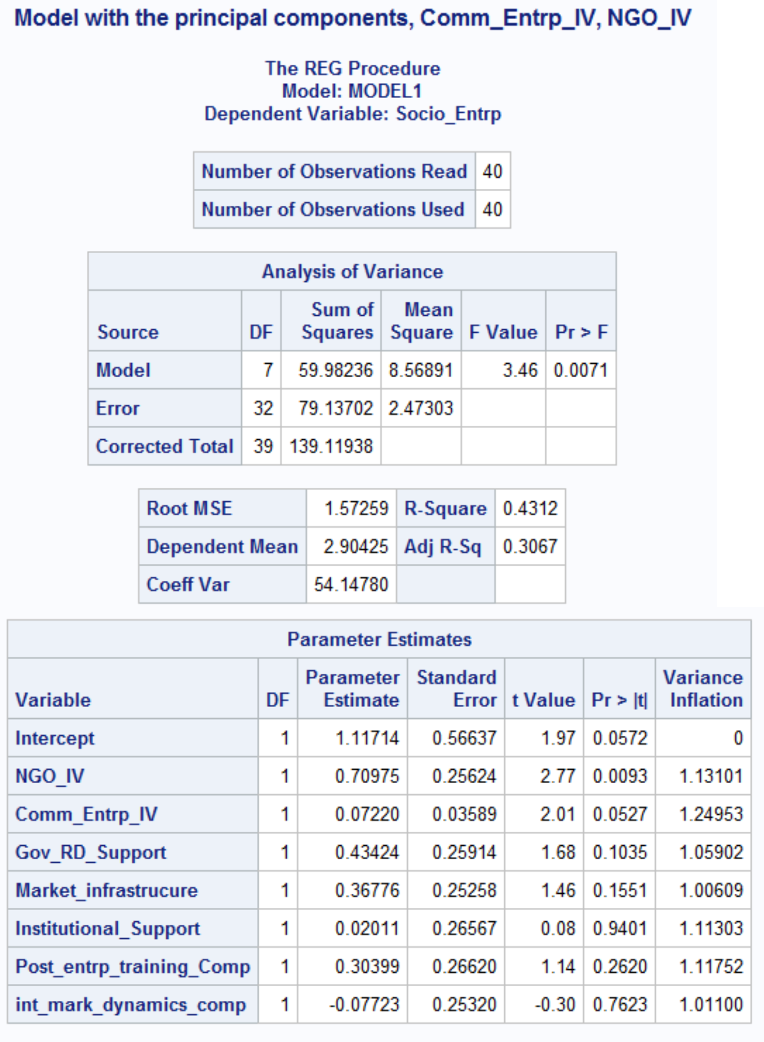

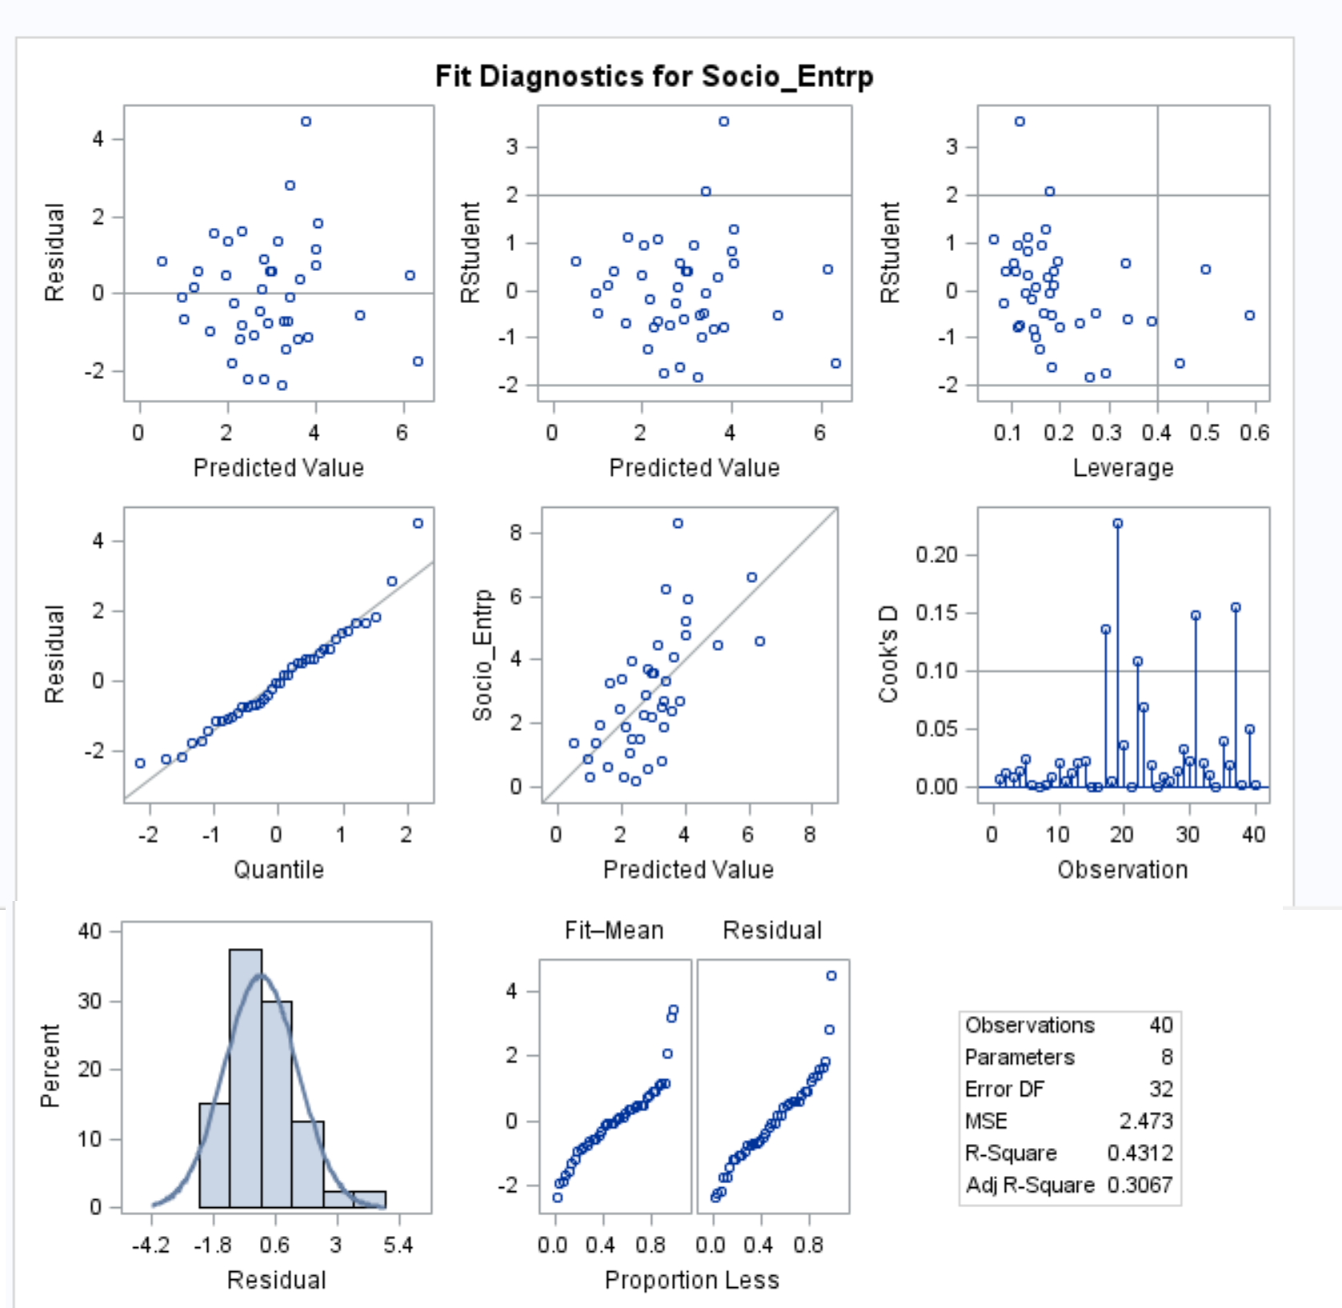

Next we present a summary of our models as well as the regression equation that incorporates our results:

|  |  |  |  |  |  |
| --- | --- | --- | --- | --- | --- |
| **Predictors =>** | NGO_IV Comm_IV | Only 5 factors | 5 Factors+ NGO_IV | 5 Factors+ Comm_IV | 5 Factors+ NGO_IV+ Comm_IV |
| **Global F Test P value =>** | 0.0008 | 0.2099 | 0.0165 | 0.0579 | 0.0071 |
| **R Square =>** | 32% | 18% | 36% | 29% | 43% |
| **Estimates/Coefficients** | **Estimates/Coefficients** | | | | |
| NGO_IV | 0.83133 |  | 0.79625 |  | 0.70975 |
| Comm_IV | 0.06076 |  |  | 0.08888 | 0.0722 |
| Gov_RD_Support |  | 0.31597 | 0.3112 | 0.46679 | 0.43424 |
| Market infrastructure | 0.38396 | 0.33996 | 0.4123 | 0.36776 |
| Institutional Support | -0.11491 | -0.14884 | 0.08853 | 0.02011 |
| Post_entrp_training | 0.62505 | 0.38173 | 0.49682 | 0.30399 |
| int_mark_dynamics | -0.0119 | -0.02471 | -0.07826 | -0.07723 |
| **P value** | **P value** | | | | |
| NGO_IV | 0.002 |  | 0.0049 |  | 0.0093 |
| Comm_IV | 0.0758 |  |  | 0.0285 | 0.0527 |
| Gov_RD_Support |  | 0.2882 | 0.2455 | 0.1096 | 0.1035 |
| Market infrastructure | 0.1986 | 0.2061 | 0.1452 | 0.1551 |
| Institutional Support | 0.6972 | 0.5759 | 0.7621 | 0.9401 |
| Post_entrp_training | 0.0401 | 0.1748 | 0.0871 | 0.262 |
| int_mark_dynamics | 0.9678 | 0.9258 | 0.7798 | 0.7623 |

The final Multiple regression model:

(Socio_Entrp) = 0.71 (NGO_IV) + 0.0722 (Comm_IV) + 0.43 (Gov_RD_Support)

+0.37 (Market_infrastructure) + 0.02 (Institutional Support)

+ 0.3 (Post_entrp_training) – 0.07 (int_mark_dynamics)

Y-hat.png is the predicted Socio_Entrp. The regression coefficient associated with NGO_IV is 0.71 suggesting that one unit increase in NGO_IV is associated with a 0.71 unit increase in Socio_Entrp. Similarly each unit increase in Comm_IV is associated with 0.07 unit increase in Socio_Entrp. Their association with socio_Entrp is also statistically significant (for comm_IV it is almost significant on the 5 % line).

Also the 5 factors are potential confounders as they do change the parameter estimates of the two IVs and the overall model remains significant at 0.0071, explaining 43% of social entrepreneurship. (For NGO_IV the estimate decreases from 0.83 to 0.71 (by 14%))

**DISCUSSION**

**In this paper, we have examined social entrepreneurship under the dual lens of social impact and financial profit through examining its correlation with both NGO entrepreneurship and commercial entrepreneurship. We found that both commercial and NGO entrepreneurship positively influence SE, with NGO entrepreneurship having a stronger impact.**

**We should acknowledge, however, that our research comes with some limitations. First and foremost, the sample of 40 countries lends us access to 40 observations which can be considered a small number with limited statistical significance. We should remind the readers here that our efforts are pioneering in this regard, as the majority of social entrepreneurship scholars use case studies due to lack of available SE secondary data. We hope that future academic endeavors will enrich our understanding of SE through collection of more comprehensive datasets; for now we pride ourselves to be among the first to have presented a quantitative analysis of social entrepreneurship (see Bacq et al., 2013; Griffiths et al., 2013; Lepoutre et al., 2013 for more examples)**. In addition, we utilized the access to 12 control variables that the GEM dataset provided; however, more variables could be incorporated into our model. We hope future academic studies will complete our attempts by including e.g. GDP, national poverty rates etc.

**In conclusion, we hope that our efforts to provide a better comprehension of social entrepreneurship through 1) presenting current literature views in a continuum format, and 2) examining the relationship between social entrepreneurship with other entrepreneurship dynamics will spur entrepreneurship research to investigate some of the questions and conceptual triggers deemed interesting in this study, in order to further the academic understanding of social ventures.**

**REFERENCES**

Austin, J., Stevenson, H., & Wei-Skillern, J. 2006. Social and commercial entrepreneurship: Same, different, or both? ***Entrepreneurship Theory and Practice***, 30: 1-22.

Bacq, S., Hartog, C., & Hoogendoorn, B. 2013. A quantitative comparison of social and commercial entrepreneurship: Toward a more nuanced understanding of social entrepreneurship organizations in context. ***Journal of Social Entrepreneurship***, 4: 40-68.

Bacq, S., & Janssen, F. 2011. The multiple faces of social entrepreneurship: A review of definitional issues based on geographical and thematic criteria. ***Entrepreneurship & Regional Development***, 23: 373-403.

Battilana, J., Lee, M., Walker, J., & Dorcey, C. 2012. In search of the hybrid ideal. ***Stanford Social Innovation Review***, 10: 50-55.

Dees, J.G. 2007. Taking social entrepreneurship seriously. ***Social Science and Modern Society***, 44: 24-31.

Dorado, S. 2006. Social entrepreneurial ventures: Different values so different process of creation, no? ***Journal of Developmental Entrepreneurship***, 11: 319-343.

Galaskiewicz, J., Bielefeld, W., & Dowell, M. 2006. Networks and organizational growth: A study of community based nonprofits. ***Administrative Science Quarterly***, 51: 337-380.

Griffiths, M.D., Gundry, L.K., & Kickul, J.R. 2013. The socio-political, economic, and cultural determinants of social entrepreneurship activity. ***Journal of Small Business and Enterprise Development***, 20: 341-357.

Haigh, N., & Hoffman, A.J. 2012. Hybrid organizations: The next chapter of sustainable business. ***Organizational Dynamics,*** 41: 126-134.

Haigh, N., Kennedy, E., & Walker, J. 2015a. Hybrid organizations as shape-shifters: Altering legal structure for strategic gain. ***California Management Review***, 57: 59-82.

Haigh, N., Walker, J., Bacq, S., & Kickul, J. 2015b. Hybrid organizations: Origins, strategies, impacts, and implications. ***California Management Review***, 57: 5-12.

Hartigan, P. 2006. It's about people, not profits. ***Business Strategy Review***, 17: 42-45.

Haugh, H. 2007. Community-led social venture creation. ***Entrepreneurship Theory and Practice***, 31: 161-182.

Katre, A., & Salipante, P. 2012. Start-up social ventures: Blending fine-grained behaviors from two institutions for entrepreneurial success. ***Entrepreneurship Theory and Practice****,* 36: 967-994.

Kirzner, I.M. 1997. Entrepreneurial discovery and the competitive market process: An Austrian approach. ***Journal of Economic Literature***, 35: 60-85.

Lee, M., & Jay, J. 2015. Strategic responses to hybrid social ventures. ***California Management Review***, 57: 126-147.

Lepoutre, J., Justo, R., Terjesen, S., & Bosma, N. 2013. Designing a global standardized methodology for measuring social entrepreneurship activity: The Global Entrepreneurship Monitor social entrepreneurship study. ***Small Business Economics***, 40: 693-714.

Light, P.C. 2006. Reshaping social entrepreneurship. ***Stanford Social Innovation Review***, 4: 47-51.

Lumpkin, G.T., Moss, T.W., Gras, D.M., Kato, S., & Amezcua, A.S. 2013. Entrepreneurial processes in social contexts: How are they different, if at all? ***Small Business Economics***, 40: 761-783.

Mair, J., & Marti, I. 2006. Social entrepreneurship research: A source of explanation, prediction, and delight. ***Journal of World Business***, 41: 36-44.

Martin, R.L., & Osberg, S. 2007. Social entrepreneurship: The case for definition. ***Stanford Social Innovation Review***, 2: 28-39.

Moore, M.H. 2001. Managing for value: Organizational strategy in for-profit, nonprofit, and governmental organizations. ***Nonprofit and Voluntary Sector Quarterly***, 29: 183-208.

Moss, T.W., Short, J.C., Payne, G., & Lumpkin, G.T. 2010. Dual identities in social ventures: An exploratory study. ***Entrepreneurship Theory and Practice****,* 35*:* 805-830.

Murphy, P.J., & Coombes, S.M. 2009. A model of social entrepreneurial discovery. ***Journal of Business Ethics****,* 87: 325-336.

Neck, H., Brush, C., & Allen, E. 2009. The landscape of social entrepreneurship. ***Business Horizons***, 52: 13-19.

Nga, J.K.H., & Shamuganathan, G. 2010. The influence of personality traits and demographic factors on social entrepreneurship start up intentions. ***Journal of Business Ethics***, 95: 259-282.

Peredo, A.M., & McLean, M. 2006. Social entrepreneurship: A critical review of the concept. ***Journal of World Business***, 41: 56-65.

Santos, F.M. 2012. A positive theory of social entrepreneurship. ***Journal of Business Ethics***, 111: 335-351.

Santos, F., Pache, A.C., & Birkholz, C. 2015. Aligning business models and organizational design for social enterprises. ***California Management Review***, 57: 36-58.

Schumpeter, J.A. 1934. ***The theory of economic development: An inquiry into profits, capital, credit, interest and business cycle***. London: Oxford University Press.

Shane, S., & Venkataraman, S. 2000. The promise of entrepreneurship as a field of research. ***Academy of Management Review***, 25: 217-226.

Short, J.C., Moss, T.W., & Lumpkin, G.T. 2009. Research in social entrepreneurship: Past contributions and future opportunities. ***Strategic Entrepreneurship Journal***, 3: 161-194.

Stevens, R., Moray, N., & Bruneel, J. 2015. The social and economic mission of social enterprises: Dimensions, measurement, validation, and relation. ***Entrepreneurship Theory and Practice***, 39: 1051-1082.

Thompson, J.L. 2002. The world of the social entrepreneur. ***International Journal of Public Sector Management***, 15: 412-431.

Townsend, D.M., & Hart, T. 2008. Perceived institutional ambiguity and the choice of organizational form in social entrepreneurial ventures. ***Entrepreneurship Theory and Practice***, 32: 685-700.

Waddock, S.A., & Post, J.E. 1991. Social entrepreneurs and catalytic change. ***Public Administration Review***, 51: 393- 401.

Weerawardena, J., & Mort, G. 2006. Investigating social entrepreneurship: A multidimensional model. ***Journal of World Business***, 41: 21-35.

Wilson, F., & Post, J.E. 2013. Business models for people, planet (& profits): Exploring the phenomena of social business, a market-based approach to social value creation. ***Small Business Economics***, 40: 715-737.

Zahra, S.A., Gedajlovic, E., Neubaum, D.O., & Shulman, J.M. 2009. A typology of social entrepreneurs: Motives, search processes and ethical challenges. ***Journal of Business Venturing***, 24: 519-532.